United States Investor | Target Country | Contract size (hectares)
Africa Atlantic Holdings Ltd. | Ghana | 10,497
Agricon Global Corporation | Ghana | 3,200
Alliance One | Malawi | 61,000
Altimo One World Agricultural Fund | Zambia | 5,000
Ardent Energy Group | Ethiopia | 200
Aslan Global Management | Mozambique | 2,500
Aslan Global Management | Tanzania | 42,000
Bionic Group | Ghana | 1,750
C3 Biodiesel | Mozambique | 5,670
Diversified International Timber Holdings | Mozambique | 80,000
Diversified International Timber Holdings | Mozambique | 200,000
Diversified International Timber Holdings | Mozambique | 182,000
Dominion Farms | Kenya | 6,000
Eco-Fuel Global | Rwanda | 10,000
EcoTechTimber Corporation | Sierra Leone | 120,000
Gadco Enterprise PLC | Ghana | 1,000
Gashaw Tahir | Ethiopia | 8,100
Genesis Global Commodities | Malawi | 10,000
Global Environment Fund | Tanzania | 28,132
Global Environment Fund | Swaziland | 31,584
Global Environment Fund | Ghana | 136,860
Global Environment Fund | South Africa | 18,000
Global Environment Fund | South Africa | 8,300
Global Environment Fund | South Africa | 3,671
Global Environment Fund | Mozambique | 160,000
Global Environment Fund | Uganda | 12,182
Groupe Blattner Elwyn | Democratic Republic of the Congo | 291,665
Groupe Blattner Elwyn | Democratic Republic of the Congo | 212,868
Groupe Blattner Elwyn | Democratic Republic of the Congo | 194,641
Groupe Blattner Elwyn | Democratic Republic of the Congo | 212,157
Groupe Blattner Elwyn | Democratic Republic of the Congo | 207,978
Groupe Blattner Elwyn | Democratic Republic of the Congo | 252,034
Herakles Capital | Cameroon | 19,843
Hulstein Warren Co. Ltd. | Ghana | 5,223
Jadora LLC, Groupe Blattner Elwyn | Democratic Republic of the Congo | 348,000
Joshua Flowers PLC | Ethiopia | 20,000
KKR & Co. L.P. | Ethiopia | 703
Millenium Challenge Corporation | Mali | 22,441
Morrell Agro Industries PLC | Ethiopia | 10,000
Nile Trading and Development | South Sudan | 600,000
Petrotech | Mali | 10,000
Prairie Texas | Ghana | 2.150
Scheer Foundation | Tanzania | 5,000
Smart Globe International | Cameroon | 12
Southern Global Inc. | Mali | 30,000
Zeyoge’s Agriculture and Industry PLC | Ethiopia | 300

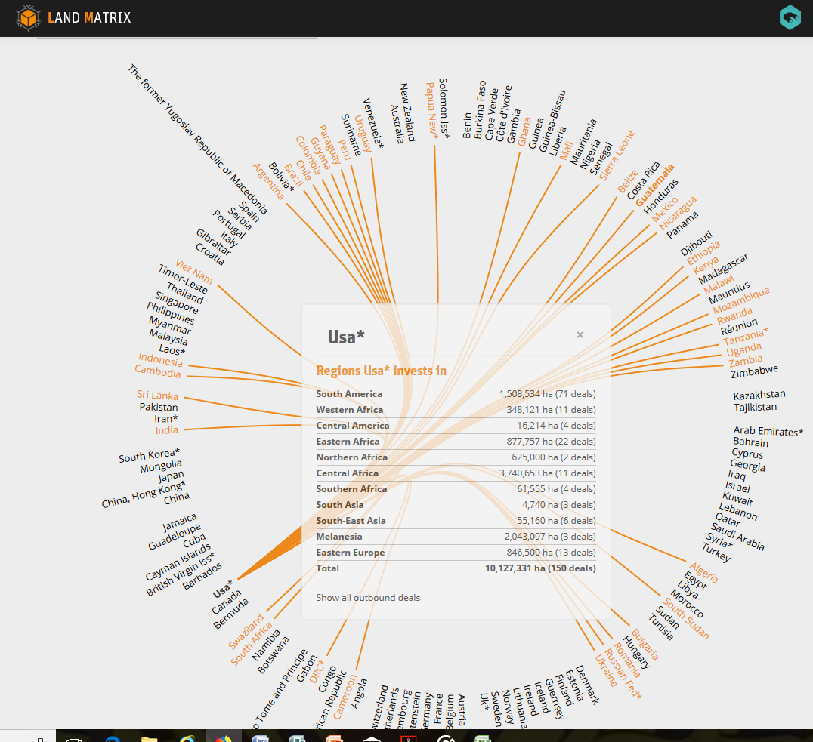

The USA Investments in Land by Country is 10,127,331 Hectares

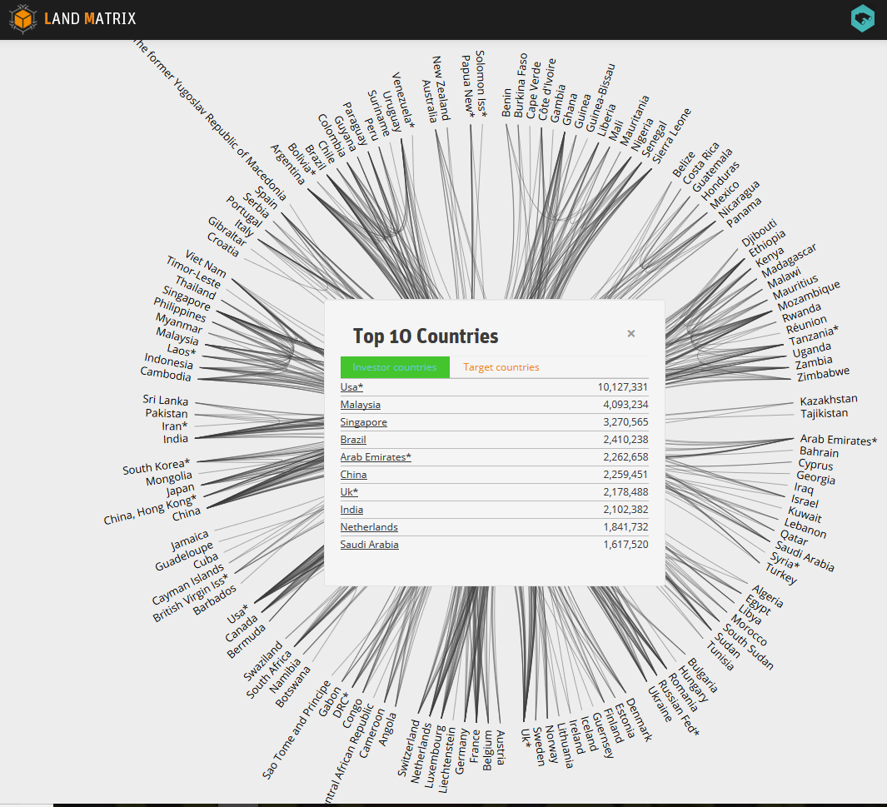

The USA ranks first of the Ten Top Investor Countries in Land worldwide with 10,127,331 Hectares

