Rev. Dr. Angelique Walker-Smith
Bio Summary
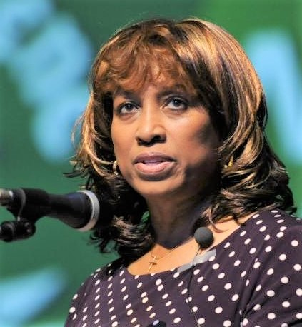
Rev. Dr. Angelique Walker-Smith is Senior Associate/Strategist for Pan African and Orthodox Faith Engagement at Bread for the World in Washington D.C. She brings extensive global, national and local experience as a faith and public engagement thought leader, journalist, speaker, broadcaster, scholar, preacher and author. In November 2023, she debuted her new book, Ahead of Her Time: Pan African Women of Faith and the Vision of Christian Unity, Mission and Justice published by World Council of Churches. She is working on a new book, A Legacy of Faith and Justice: Pan African Advocacy and Leadership for Ending Hunger that will debut in DC in June, 2025. In September 2022 she was elected President of the World Council of Churches (WCC) from North America-Turtle Island at the WCC World Assembly in Karlsruhe, Germany in 2022. She is also the Co- Convener of the Pan African Women of Faith/Pan African Women’s Ecumenical Empowerment Network (PAWEEN) and Africans and the Africans in Diaspora Network (AAD). She is the former Executive Director/Minister of the Church Council in Greater Indianapolis, Indiana and Church Council in Trenton, NJ. She was also the first woman to serve as President of Historic Black Churches of Christian Churches Together (CCT) USA and currently serves in governance roles with the National Council of Churches. She also serves on the Justice and Reconciliation Commission of the Baptist World Alliance. She is a member of the Home Mission Board of the National Baptist Convention USA Inc.

President Clinton, Senator Richard Lugar, former Indiana Governor/Vice President of the USA, the Honorable Mike Pence, and two of her alma maters, Yale University Divinity School and Kent State University have awarded her with high distinctions of leadership. Recently she was awarded the Shirley Chisolm Award from the Conference of National Black Churches (CNBC), the Figel Award for Ecumenism by the Washington Theological Consortium in Washington DC and Callie House award from the Samuel DeWitt Proctor Conference and McCormick Theological Seminary. She is also a member of the inaugural class of Historymakers (USA Smithsonian Museum National Archive of notable People of African Descent) and a founding delegate of the new United Nations (UN) Permanent Forum on People of African Descent. She received her doctorate degree from Princeton Theological Seminary, Master of Divinity from Yale University Divinity School and Bachelor of Arts degree from Kent State University. On June 7th, 2024, she received an honorary doctorate from the historic Wayland Baptist Theological Seminary which began as the Baptist Training Union founded by free and escaped enslaved persons in 1812.
1/27/25

